**OAK-SoM-Pro-S3 – RVC3 with eMMC Flash**

# Features

* RVC3 VPU
* Quad-core Arm* A53 CPU with Linux*

on chip

* 16GB eMMC 5.1
* 128MB QSPI NOR Flash
* 32Kb I2C EEPROM
* USB3.1, gen2 10gbps
* PCIe x2 (ext. ref clk)
* 2x 4-Lane MIPI CSI-2 D-PHY
* 2x 2-Lane MIPI CSI-2 D-PHY
* QSPI, SDIO, UART, I2C, I2S
* Boot Modes Supported: eMMC, USB
* On-board power generation

# Applications

* Industrial automation
* Robotics and autonomy
* Security systems
* Remote intelligence

# Variants

OAK-SoM-Pro-S3 options are listed below based on VPU used on the SoM:

* RVC3 with external DRAM:
* 4Gbit
* 8Gbit
* 16Gbit (default)

# Description

The Luxonis OAK-SoM-Pro-S3 is a system-on-module (SoM) designed for integration into a top-level system with a need for a low-power, 4 TOPS AI vision system. The OAK-SoM-Pro-S3 interfaces with the system through two 10-gbps-rated 100-pin DF40C-100DP-0.4V(51) board-to-board mezzanine connectors which carry all signal I/O as well as 5V input. The on-board SMPS system regulates the 5V input and provides all necessary digital and analog power. An auxiliary power port is offered to interface without connection to a baseboard.

Core digital electronics on the OAK-SoM-Pro-S3 include the RVC3 VPU along with 16Gbit DDR, a 16GB eMMC 5.1 flash device, 128MB QSPI NOR flash, and 32kb EEPROM.

USB 3.1 Gen2, QSPI, UART, I2C, 1-lane PCIe, and SDIO are all broken out from the SoM and routed through the mezzanine connectors to the system. Additionally, the OAK-SoM-Pro-S3 exposes two 2-lane MIPI CSI-2 D-PHY channels and two 4-lane MIPI CSI-2 D-PHY channels, allowing for multiple camera inputs.

I2S interface with APB data 32 bit bus width is exposed; one output and 3 stereo inputs give the ability to connect multiple microphones and one external audio device.

GPIO Boot selection, JTAG, and additional RVC3 GPIOs are exposed as well. A 10-pin JTAG connector is also provided on-board to allow for debug without the need for a baseboard.

The SoM can be booted via USB and eMMC.

SoM power consumption is use-case dependent, but typical consumption is under 7.5W with thermal mitigation.

**Device Information**

|  |  |
| --- | --- |
| **PART NUMBER** | **SIZE (W x L x H)1** |
| OAK-SoM-Pro-S3 | 30mm x 45mm x 17.5mm |

1. Including components and heatsink

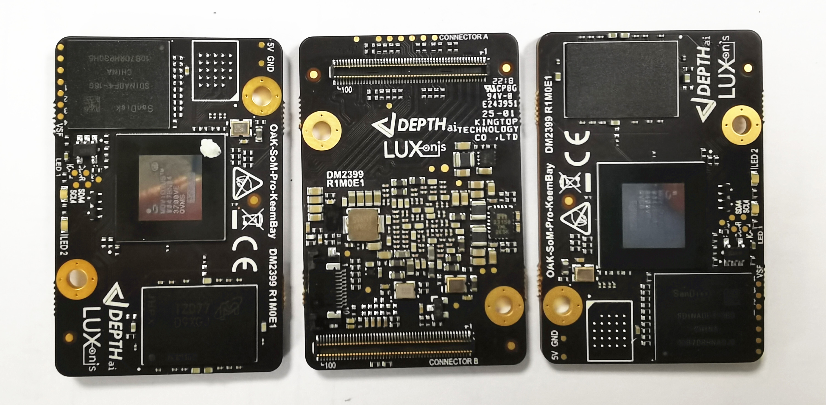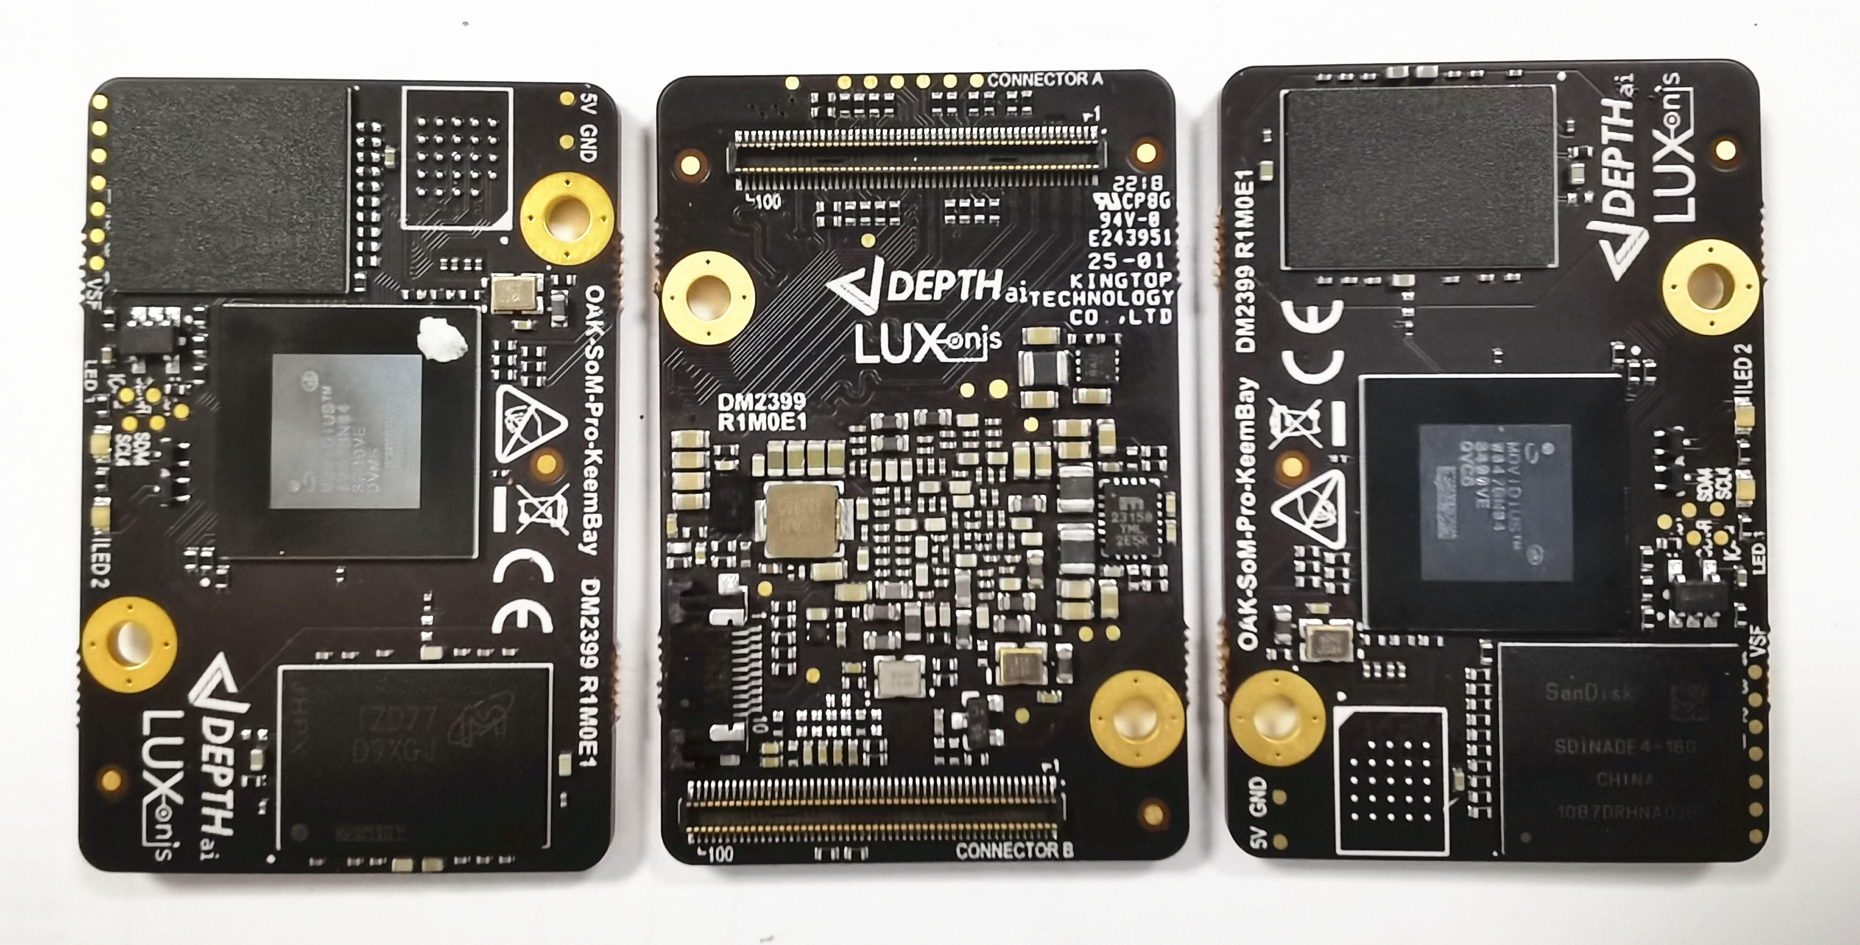

Figure 1 - Top and Bottom of OAK-SoM-Pro-S3 PCBA

**Table of Contents**

1 Features 1

2 Applications 1

3 Variants 1

4 Description 1

5 Block Diagram 4

5 Electrical Characteristics 5

5.1 Absolute Maximum Ratings1 5

5.2 Recommended Operating Conditions 5

6 SoM Connector 6

6.1 Pinout 6

6.2 I2C 8

6.2.1 EEPROM I2C0 Address Usage 8

6.2.2 RGB Camera I2C1 Address Usage 8

6.2.3 Stereo Camera I2C2 Address Usage 8

6.3 MIPI 9

6.4 I2S 9

6.5 PCIe 9

6.6 USB3.1 Gen2 10

6.7 eMMC 10

6.8 PGOOD 10

6.9 WAKEUP 10

6.10 _RST 11

6.11 Camera Reference Clocks 11

6.12 Camera Reset Signals 11

6.13 1.8V Shared SPI0 (QSPI) 11

6.14 3.3V GPIO Bank 12

6.15.1 3.3V GPIO Bank - SDIO 13

6.16 1.8V GPIO 13

6.17 JTAG 15

7 BOOT Modes 15

8 SoM LEDs 15

8 Mechanical Information 17

8.1 OAK-SoM-Pro-S3 Dimensions 17

8.2 Recommended Mounting Configuration 18

8.3 OAK-SoM-Pro-S3 Mounting Holes 18

8.4 SoM Clearance 18

9 Thermal Information 18

10 Revision History 19

# Block Diagram

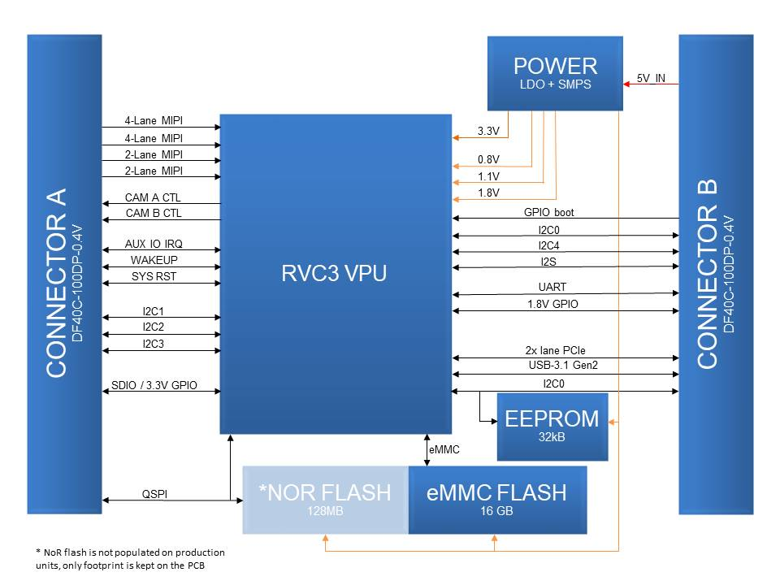

Figure 2 - Schematic Block Diagram

# 5 Electrical Characteristics

## 5.1 Absolute Maximum Ratings1

|  |  |  |  |  |
| --- | --- | --- | --- | --- |
| **SYMBOL** | **RATINGS** | **MIN** | **MAX** | **UNIT** |
| **V**IN | External input supply voltage range.2 | 3.6 | 5.5 | V |
| **V**I/O_1V8 | Input voltage SoM I/O for 1.8V logic | -0.3 | 2.0 | V |
| **V**I/O_3V3 | Input voltage SoM I/O for 3.3V logic | -0.3 | 3.6 | V |
| **I**I/O | IO output current drive strength | 2 | 12 | mA |
| **T**J | Junction temperature. |  | 105 | C |
| **T**STG | Storage temperature. | -30 | 150 | C |

## 5.2 Recommended Operating Conditions

|  |  |  |  |  |  |
| --- | --- | --- | --- | --- | --- |
| **SYMBOL** | **RATINGS** | **MIN** | **TYP** | **MAX** | **UNIT** |
| **V**IN | External input supply voltage range.2 | 4.5 | 5.0 | 5.25 | V |
| **V**I/O_1V8 | Input voltage SoM I/O for 1.8V logic | 0 |  | 1.8 | V |
| **V**I/O_3V3 | Input voltage SoM I/O for 3.3V logic | 0 |  | 3.3 | V |
| **P**Q | Quiescent power draw3 |  | RBD |  | W |
| **P**IDLE | Idle power draw4 |  | TBD |  | W |
| **P**INFR | Inference power draw5 |  | 5.5 |  | W |
| **T**A | Ambient operating temperature6 |  | 25 | 50 | °C |
| **T**J | Junction temperature.6 |  |  | 105 | °C |

1. Stresses beyond those listed under *Absolute Maximum Ratings* may cause permanent damage to the device. These are stress ratings only, which do not imply functional operation of the device at these or any other conditions beyond those indicated under *Recommended* *Operating Conditions*. Exposure to absolute-maximum-rated conditions for extended periods may affect device reliability.
2. Applies to 5V input pins only
3. With SoM in reset
4. RVC3 booted to base mode via USB
5. MobilenetSSDV2 detector, 30fps
6. With default Luxonis passive heatsink, running Mobilenet-SSDV2 30fps. Custom or active thermal solutions are recommended in ambient environments >50C, and/or for highly demanding inference operations >2.5W.

# 6 SoM Connector

## 6.1 Pinout

The following contains the pinout of 100-pin DF40C-100DP-0.4V(51) connector, part A.



Figure 3 - Schematic Pinout, Connector A

The following contains the pinout of 100-pin DF40C-100DP-0.4V(51) connector, part B.



Figure 4 - Schematic Pinout, Connector J2

## 6.2 I2C

The OAK-SoM-Pro-S3 SoM offers four dedicated I2C interfaces, I2C0 (EEPROM I2C), I2C1 (CAMA_I2C), I2C2 (CAMB_I2C), I2C3 (CAMD_I2C) and one I3C1 (backwards compatible with I2C) all with 2.2Kohm pull-up resistors (SDA & SCL) to the on-SoM 1.8V rail. For custom baseboard designs, all four I2C and one I3C interfaces are available and routed through the mezzanine connectors. I2C0 is already used for EEPROM which located on SoM. On baseboards, preferably the I2C1 interface is used for communication with the RGB color camera, the I2C2 interface is used to communicate with the pair of stereo cameras, the I2C3 is used for additional cameras or other peripherals such as programmability of PCIe. The I3C1 is typically unused but accessible through test points or connector pads.

### 6.2.1 EEPROM I2C0 Address Usage

The 32K I2C Serial EEPROM on most Luxonis baseboards is used for revision detect and a storage location for RTL8111HS driver if applicable. With functional address lines 7-bit address for EEPROM is set to 0x50. Use of the I2C0 interface on other components is possible, but with consideration of the existing usage of the EEPROM.

### 6.2.2 RGB Camera I2C1 Address Usage

The IMX378 RGB camera on most Luxonis baseboards uses some specific addresses as seen in Figure . Use of the I2C1 interface on other components is possible, but with consideration of the existing usage of the RGB camera.

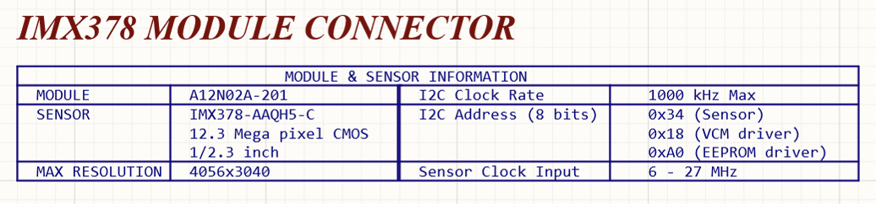

Figure 5 - Baseboard I2C1 RGB Camera Module Usage

### 6.2.3 Stereo Camera I2C2 Address Usage

The pair of OV9282 sensors comprising the stereo pair some Luxonis baseboards uses specific addresses as seen in Figure . Use of the I2C2 interface on other components is possible, but with consideration of the existing usage of the stereo camera.

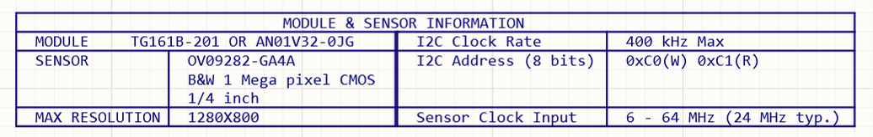

Figure 6 - Baseboard I2C2 Stereo Camera Module Usage

## 6.3 MIPI

Four MIPI CSI-2 DPHYv1.2 interfaces are available as input to the SoM. Two are 4-lane interfaces, and the other two interfaces are 2-lane each, all allowing a maximum of 2.1Gbps per lane.

For each of the four camera interfaces, the inter-pair delay of that interface is matched to the clock pair within +/-1ps, and all pairs are routed with 100ohm differential impedance.

## 6.4 I2S

Three stereo inputs for microphones and one audio output supporting I2S are available routed thorough mezzanine connector. With use of word select up to six microphones can be connected to the interface and two channel stereo audio device can be attached to the SoM.

|  |  |  |  |  |  |  |
| --- | --- | --- | --- | --- | --- | --- |
| **Pin/**  **Conn. #** | **Pin name / Primary Function** | **SoM GPIO** | **Alt. 1** | **PU/PD on SoM** | **Pin Type** | **Description** |
| 21/B | I2S2_I/O_SD0 | IO_2 |  |  | 1.8V GPIO | Typically used for I2S interface but can be reconfigured to any other GPIO. |
| 25/B | I2S2_ I/O _SD1 | IO_3 |  |  | 1.8V GPIO | Typically used for I2S interface but can be reconfigured to any other GPIO. |
| 27/B | I2S2_I/O _SD2 | IO_4 |  |  | 1.8V GPIO | Typically used for I2S interface but can be reconfigured to any other GPIO. |
| 23/B | I2S2_ I/O_SD3 | IO_5 |  |  | 1.8V GPIO | Typically used for I2S interface but can be reconfigured to any other GPIO. |
| 19/B | I2S2_WS | IO_1 |  |  | 1.8V GPIO | Typically used for I2S interface but can be reconfigured to any other GPIO. |
| 17/B | I2S2_SCK | IO_0 |  |  | 1.8V GPIO | Typically used for I2S interface but can be reconfigured to any other GPIO. |

Table 1 – I2S Pin Configuration

## 6.5 PCIe

PCIe Gen 2 lane expansion bus is routed through mezzanine connector B. It supports all standard requirements of PCIe Rev 4.0, version 1.0. External reference clocking should be used for EP/RC applications. The reference clock signal used must be 100MHz.

|  |  |  |  |  |  |  |
| --- | --- | --- | --- | --- | --- | --- |
| **Pin/**  **Conn. #** | **Pin name / Primary Function** | **SoM GPIO** | **Alt. 1** | **PU/PD on SoM** | **Pin Type** | **Description** |
| 95/B | SDS_TXD1_P | PCIe_TXD1_P |  | AC coupling | SDS | PCIe x2 lane transmitter data differential pair positive. Board implements AC coupling caps on board. |
| 97/B | SDS_TXD1_N | PCIe_TXD1_N |  | AC Coupling | SDS | PCIe x2 lane transmitter data differential pair negative. Board implements AC coupling caps on board. |
| 89/B | SDS_RXD1_P | PCIe_RXD1_P |  |  | SDS | PCIe x2 lane receiver data differential pair positive. |
| 91/B | SDS_RXD1_N | PCIe_RXD1_N |  |  | SDS | PCIe x2 lane receiver data differential pair negative. |
| 81/B | SDS_IO_CLKI_N | PCIe_CLKI_N |  |  | SDS | PCIe differential reference clock input from clock generator negative. |
| 83/B | SDS_IO_CLKI_P | PCIe_CLKI_P |  |  | SDS | PCIe differential reference clock input from clock generator positive. |
| 48/B | SDS_IO_CLKO_N | PCIe_CLKO_N |  |  | SDS | PCIe differential reference clock output from clock generator negative. |
| 50/B | SDS_IO_CLKO_P | PCIe_CLKO_P |  |  | SDS | PCIe differential reference clock output from clock generator positive. |
| 69/B | SDS_TXD0_P | PCIe_TXD0_P |  | AC coupling | SDS | PCIe x2 lane transmitter data differential pair positive. Board implements AC coupling caps on board. |
| 71/B | SDS_TXD0_N | PCIe_TXD0_N |  | AC Coupling | SDS | PCIe x2 lane transmitter data differential pair negative. Board implements AC coupling caps on board. |
| 75/B | SDS_RXD0_P | PCIe_RXD0_P |  |  | SDS | PCIe x2 lane receiver data differential pair positive. |
| 77/B | SDS_RXD0_N | PCIe_RXD0_N |  |  | SDS | PCIe x2 lane receiver data differential pair negative. |
| 65/B | PCIe_CLKREQ_N | IO_78 |  |  | PCIe | Ref Clk request Signal |
| 63/B | PCIe_PERST | IO_77 |  |  | PCIe | Actve Low Reset Input to the add in Card. |

Table 2 – PCIe Pin Configuration

## 6.6 USB3.1 Gen2

USB3.1 is exposed it can operate as a device. Maximum of 10Gbps serial data rate can be achieved.

|  |  |  |  |  |  |  |
| --- | --- | --- | --- | --- | --- | --- |
| **Pin/**  **Conn. #** | **Pin name / Primary Function** | **SoM GPIO** | **Alt. 1** | **PU/PD on SoM** | **Pin Type** | **Description** |
| 84/B | USB_TX_N | USB_TX_N |  |  | USB3 | USB 3.0 SSTX (-) / No AC caps on SoM / 0.5ps intra-pair tuning / 90ohm +/-10% |
| 86/B | USB_TX_P | USB_TX_P |  |  | USB3 | USB 3.0 SSTX (+) / No AC caps on SoM / 0.5ps intra-pair tuning / 90ohm +/-10% |
| 96/B | USB_RX_P | USB_RX_P |  |  | USB3 | USB 3.0 SSRX (+) / 0.5ps intra-pair tuning / 90ohm +/-10% |
| 98/B | USB_RX_N | USB_RX_N |  |  | USB3 | USB 3.0 SSRX (-) / 0.5ps intra-pair tuning / 90ohm +/-10% |
| 90/B | USB_D_N | USB_D_N |  |  | USB2 | USB 2.0 (-) / 2ps intra-pair tuning / 90ohm +/-10% |
| 92/B | USB_D_P | USB_D_P |  |  | USB2 | USB 2.0 (+) / 2ps intra-pair tuning / 90ohm +/-10% |
| 90/B | SOC_USB_D_N | SOC_USB_D_N |  |  | SOC_USB2 | USB 2.0 (-) / 2ps intra-pair tuning / 90ohm +/-10%, SoC USB factory debug port |
| 92/B | SOC_USB_D_P | SOC_USB_D_P |  |  | SOC_USB2 | USB 2.0 (+) / 2ps intra-pair tuning / 90ohm +/-10%, SoC USB factory debug port |
| 80/B | 5V/VBUS | 5V/VBUS |  |  | PWR | USB UFP VBUS sense input for VBUS detect. Can be tied to 5V to enable RVC3 USB for embedded applications. |

Table 3 - USB Pin Configuration

## 6.7 eMMC

16GB eMMC with 5.1 host controller flash storage device on SoM can be used as a permanent storage medium. It can also be used as storage location for firmware boot images. Fastest recommended eMMC boot mode can be selected with boot mode number 0x1f. Using 8 parallel data lines you can achieve 3Gbits per second data rate and 1.5Gbits data rate for HS400 and HS200 mode respectively.

## 6.8 PGOOD

PGOOD is a 1.8V open-drain output from the SoM PMIC and is pulled high when the PMIC evaluates power is good. PGOOD has a 10Kohm pull-up resistor to the on-SoM 1.8V rail.

This pin should be left floating if unused or tied to a high-impedance input to sense PGOOD. Do not pull or tie PGOOD to GND.

## 6.9 WAKEUP

WAKEUP is a 1.8V input to the SoM which is pulled to GND through a 1Kohm resistor on SoM. If driven high and sensed during the rising edge of _RST power-on-reset, the on-chip e-fuse is used for boot selection. At present, this functionality is not used on any Luxonis SoM.

The WAKEUP pin was originally intended for waking the SoM from deep sleep mode, but this functionality is not supported on Luxonis SoMs. However, any IO can be used to trigger an interrupt and wake the SoM.

## 6.10 _RST

_RST is the active-low VPU reset input. _RST has a 1.8V 10Kohm pull-up resistor on the SoM, and can be driven low from the baseboard to reset the RVC3.

## 6.11 Camera Reference Clocks

Two pins are used to provide a 24MHz reference clock to the image sensor ICs on the baseboard. These signals are on the CAMA_CLK and CAMB_CLK pins of the SoM interface connector. Each signal has a 121Kohm, pull down on the SoM. CAMA_CLK is meant to be used for RGB cameras and CAMB_CLK for grayscale stereo pair cameras. It is possible to create additional reference clocks for additional cameras by reconfiguring an IO pin.

## 6.12 Camera Reset Signals

Three pins are used for individually resetting or powering down the RGB and stereo pair cameras. These signals are CAMA_RST, CAM_B_D_PWM, and CAM_B_PWDN_N, for both RGB, LEFT, and RIGHT cameras respectively. Each of these signals is 1.8V and are active-low. No pull-up or pull-down resistors are on these signals on the SoM.

## 6.13 1.8V Shared SPI0 (QSPI)

The signals with prefix “SPI1” are part of a QSPI bus which is shared with the optional on-SoM NOR flash. Note the signal configuration details in Table 4 (refer to the [OAK-SoM-Pro-S3 IO TABLE](https://github.com/luxonis/depthai-hardware/blob/master/SoMs/OAK-SoM-Pro-S3/OAK-SoM-Pro-S3_IO_TABLE.xlsx) for more details). All signals related to SPI1 are delay-matched on the SoM to +/-100ps to the connector interface.

|  |  |  |  |  |  |  |
| --- | --- | --- | --- | --- | --- | --- |
| **Pin/**  **Conn. #** | **Pin name / Primary Function** | **SoM GPIO** | **Alt. 1** | **PU/PD on SoM** | **Pin Type** | **Description** |
| 60/A | SPI0_SS_3 | IO_65 |  |  | 1.8V GPIO | GPIO, or can be configured as second CS for SPI0, MX in Controller or Peripheral mode. / +/-100ps inter-SPI0 |
| 70/A | SPI0_SS_0 | IO_16 |  | PU: 1kR/1.8V | 1.8V GPIO | Hardwired to SoM on-board NOR S# / +/-100ps inter-SPI0 |
| 74/A | SPI0_SCK | IO_15 |  |  | 1.8V GPIO | Hardwired to SoM on-board NOR C / +/-100ps inter-SPI0 |
| 62/A | SPI0_SIO0 | IO_17 |  |  | 1.8V GPIO | Hardwired to SoM on-board NOR DQ0 / +/-100ps inter-SPI0 |
| 64/A | SPI0_SIO1 | IO_18 |  |  | 1.8V GPIO | Hardwired to SoM on-board NOR DQ1 / +/-100ps inter-SPI0 |
| 66/A | SPI0_SIO2 | IO_19 |  | PU: 1kR/1.8V | 1.8V GPIO | Hardwired to SoM on-board NOR W#/DQ2 / +/-100ps inter-SPI0 |
| 68/A | SPI0_SIO3 | IO_20 |  | PU: 1kR/1.8V | 1.8V GPIO | Hardwired to SoM on-board NOR DQ3/HOLD# / +/-100ps inter-SPI0 |

Table 4 - SPI0 Pin Configuration

With the NOR flash unpopulated the SPI1 bus can be used by the RVC3 in either controller or peripheral mode. With the RVC3 in controller mode, SPI1_SS_3 and SPI0_SS_0 can be used as chip selects for any baseboard peripherals, and additional baseboard chip selects can be configured by using IOs, if required. With the RVC3 in peripheral mode, either the SPI1_SS_3 or SPI1_SS_0 can be used by the baseboard controller to select the RVC3 as a peripheral. Unlike for controller mode, in peripheral mode, IOs cannot be configured as chip selects for the RVC3, only SPI1_SS_3 and SPI1_SS_0 can be used for this purpose.

With the NOR flash populated, the SPI1 bus can still be used by the RVC3 in either controller or peripheral mode, but the NOR flash now occupies the SPI1_SS_0 location so some care must be taken to avoid contention. With the NOR flash populated, and the RVC3 is in controller mode, the SPI0_SS_0 selects the NOR flash. SPI1_SS_3 (or other reconfigured IO) can be used as a second chip select for baseboard peripherals. When in peripheral mode SPI1_SS_3 should be used as the chip select for the peripheral RVC3 to avoid contention when communicating with NOR flash using SPI1_SS_0.

Note that when an external controller is accessing the NOR flash on the SoM, the RVC3 must not be allowed to access at the same time. Asserting _RST for the RVC3 is an option to prevent this contention.

## 6.14 3.3V GPIO Bank

The SoM offers six GPIO which are 3.3V signaling for easy interface to common peripherals and devices with 3.3V signaling. These GPIO offer several configurations including SDIO, UART, PWM, and I2C, along with general purpose IO and are listed in Table (refer to the [OAK-SoM-Pro-S3 IO TABLE](https://github.com/luxonis/depthai-hardware/blob/master/SoMs/OAK-SoM-Pro/OAK-SoM-Pro_IO_TABLE.xlsx) for more details).

|  |  |  |  |  |  |  |  |  |  |
| --- | --- | --- | --- | --- | --- | --- | --- | --- | --- |
| **Pin/**  **Conn. #** | **Pin name / Primary Function** | **SoM GPIO** | **Alt. 1** | **Alt. 2** | **Alt. 3** | **Alt. 4** | **PU/PD on SoM** | **Pin Type** | **Description** |
| 40/A | IO_34_3V3 | IO_34 | sd_hst0_dat_0 | spi2_dio_2 | pwm_0 | I2C3_SDA | PU: 40.2kR/1.8V | 3.3V GPIO | 3.3V GPIO. Note PU/PD resistors that are configured for SDIO, but also compatible with SPI. / +/-100ps inter-SD_HST |
| 61/A | IO_32_3V3 | IO_32 | sd_hst0_clk |  |  |  | PU: 40.2kR/1.8V | 3.3V GPIO | 3.3V GPIO. Note PU/PD resistors that are configured for SDIO, but also compatible with SPI. / +/-100ps inter-SD_HST |
| 63/A | IO_33_3V3 | IO_33 | sd_hst0_cmd |  |  | I2C3_SCL | PU: 40.2kR/1.8V | 3.3V GPIO | 3.3V GPIO. Note PU/PD resistors that are configured for SDIO, but also compatible with SPI. / +/-100ps inter-SD_HST |
| 32/A | IO_37_3V3 | IO_37 | sd_hst0_dat_3 | spi2_cs_0 | pwm_3 | UART3_TX | PD: 300kR/GND | 3.3V GPIO | 3.3V GPIO. Note PU/PD resistors that are configured for SDIO, but also compatible with SPI. / +/-100ps inter-SD_HST |
| 36/A | IO_36_3V3 | IO_36 | sd_hst0_dat_2 | spi2_sclk |  |  | PU: 40.2kR/1.8V | 3.3V GPIO | 3.3V GPIO. Note PU/PD resistors that are configured for SDIO, but also compatible with SPI. / +/-100ps inter-SD_HST |
| 38/A | IO_35_3V3 | IO_35 | sd_hst0_dat_1 | spi2_dio_3 |  | UART3_RX | PU: 40.2kR/1.8V | 3.3V GPIO | 3.3V GPIO. Note PU/PD resistors that are configured for SDIO, but also compatible with SPI. / +/-100ps inter-SD_HST |

Table 5 - 3.3V GPIO Pin Configuration

### 6.15.1 3.3V GPIO Bank - SDIO

The 3.3V GPIO bank is nominally configured for use with SDIO, as appropriate pull-up and pull-down resistors exist on the SoM. CLK, CMD, and DAT[0:3] are available for use. Optional signals such as card detect can be implemented using the 1.8V GPIO.

## 6.16 1.8V GPIO

The default IO voltage for all GPIO is 1.8V, with the exceptions of the 3.3V GPIO listed in Table . Each SPGIO can be muxed to alternate functionality as described in Table (refer to the [OAK-SoM-Pro-S3 IO TABLE](https://github.com/luxonis/depthai-hardware/blob/master/SoMs/OAK-SoM-Pro/OAK-SoM-Pro_IO_TABLE.xlsx) for more details). In addition to muxed functionality, each IO is fully user-programmable with support or four output drive strengths (2mA, 4mA, 8mA, 12mA), selectable output slew-rate (slow/fast), open-drain output mode, LVCMOS/LVTTL compatible input modes with selectable hysteresis, programmable pull-up/pull-down input options, power-on-start capability, and no requirements for power sequencing. Additionally, 100MHz frequency can be achieved with less than 15pF external load, or up to 125MHz with less than 10pF external load.

|  |  |  |  |  |  |  |  |
| --- | --- | --- | --- | --- | --- | --- | --- |
| **Pin/**  **Conn. #** | **Pin name / Primary Function** | **SoM GPIO** | **Alt. 1** | **Alt. 2** | **PU/PD on SoM** | **Pin Type** | **Description** |
| 28/A | CAMA_CLK | IO_21 |  |  | PD: 121kR/GND | 1.8V GPIO | 24MHz reference clock for Camera A PLL |
| 33/A | CAMA_I2C_SDA | IO_25 | pwm5 |  | PU: 2.2kR/1.8V | 1.8V GPIO | I2C data for Camera A |
| 34/A | CAMA_RST | IO_8 |  |  |  | 1.8V GPIO | Camera A reset/power down. |
| 35/A | CAMA_I2C_SCL | IO_24 |  |  | PU: 2.2kR/1.8V | 1.8V GPIO | I2C clock for Camera A |
| 42/A | CAMFS_2L | IO_13 |  |  |  | 1.8V GPIO | Auxiliary GPIO for cameras sync/trigger. Reserved for interrupt FSIN (Frame sync input) for the cameras used. |
| 45/A | PWR_BTN | IO_11 |  |  |  | 1.8V GPIO | User configurable IO meant as a software controller shutdown button |
| 47/A | RST_BTN | IO_70 |  |  |  | 1.8V GPIO | User configurable IO meant as a software reset button |
| 49/A | LED1 | IO_69 |  |  |  | 1.8V GPIO | User configurable IO meant as a LED control pin |
| 51/A | LED1 | IO_12 |  |  |  | 1.8V GPIO | User configurable IO meant as a LED control pin |
| 55/A | IO_79 | IO_79 |  |  |  | 1.8V GPIO | General purpose IO |
| 59/A | IO_71 | IO_71 |  |  |  | 1.8V GPIO | General purpose IO |
| 60/A | SPI1_SS_3 | IO_65 | SPI1_SS_3 |  |  | 1.8V GPIO | GPIO, or can be configured as second CS for SPI0, MX in Controller or Peripheral mode. / +/-100ps inter-SPI1 |
| 62/A | SPI1_SIO0 | IO_17 |  |  |  | 1.8V GPIO | Hardwired to SoM on-board NOR DQ0 / +/-100ps inter-SPI1 |
| 64/A | SPI11_SIO1 | IO_18 |  |  |  | 1.8V GPIO | Hardwired to SoM on-board NOR DQ1 / +/-100ps inter-SPI0 |
| 65/A | CAML_ PWR | IO_7 |  |  |  | 1.8V GPIO | Camera left reset/power down. |
| 66/A | SPI1_SIO2 | IO_19 |  |  | PU: 1kR/1.8V | 1.8V GPIO | Hardwired to SoM on-board NOR W#/DQ2 / +/-100ps inter-SPI1 |
| 67/A | CAMR_P WR | IO_6 |  |  |  | 1.8V GPIO | Camera right reset/power down. |
| 68/A | SPI0_SIO3 | IO_20 |  |  | PU: 1kR/1.8V | 1.8V GPIO | Hardwired to SoM on-board NOR DQ3/HOLD# / +/-100ps inter-SPI1 |
| 69/A | IO_56 | IO_56 |  |  |  | 1.8V GPIO | General purpose 1.8V IO |
| 70/A | SPI1_SS_0 | IO_16 |  |  | PU: 1kR/1.8V | 1.8V GPIO | Hardwired to SoM on-board NOR S# / +/-100ps inter-SPI1 |
| 73/A | CAMST_CLK | IO_22 |  |  | PD: 121kR/GND | 1.8V GPIO | 24MHz reference clock for Stereo Camera PLL |
| 74/A | SPI1_SCK | IO_15 |  |  |  | 1.8V GPIO | Hardwired to SoM on-board NOR C / +/-100ps inter-SPI1 |
| 77/A | CAMB_I2C_SCL | IO_26 |  |  | PU: 2.2kR/1.8V | 1.8V GPIO | Camera B I2C SDA. Can be used as GPIO. |
| 79/A | CAMB_I2C_SDA | IO_27 |  |  | PU: 2.2kR/1.8V | 1.8V GPIO | Camera B I2C SCL. Can be used as GPIO. |
| 78/A | IO_28 | IO_28 | I2C3_SCL |  | PU: 2.2kR/1.8V | 1.8V GPIO | Camera C I2C SCL (if applicable). Can be used as GPIO |
| 80/A | IO_29 | IO_29 | I2C3_SDA |  | PU: 2.2kR/1.8V | 1.8V GPIO | Camera C I2C SDA (if applicable). Can be used as GPIO |

Table 6 - 1.8V GPIO Pin Configuration (connector A)

|  |  |  |  |  |  |  |  |
| --- | --- | --- | --- | --- | --- | --- | --- |
| 31/B | ETH_PHY_RXD0 | IO_52 |  |  |  | 1.8V GPIO | RGMII data bus |
| 33/B | ETH_PHY_RXD1 | IO_53 |  |  |  | 1.8V GPIO | RGMII data bus |
| 34/B | I2C0_SCL | IO_66 |  |  | PU: 2.2kR/1.8V | 1.8V GPIO | EEPROM I2C SCL (if applicable). Can be used as GPIO |
| 35/B | ETH_PHY_RXD2 | IO_54 |  |  |  | 1.8V GPIO | RGMII data bus |
| 36/B | I2C0_SDA | IO_67 |  |  | PU: 2.2kR/1.8V | 1.8V GPIO | EEPROM I2C SDA (if applicable). Can be used as GPIO |
| 37/B | ETH_PHY_RXD3 | IO_55 |  |  |  | 1.8V GPIO | RGMII data bus |
| 41/B | ETH_PHY_TXD0 | IO_48 |  |  |  | 1.8V GPIO | RGMII data bus |
| 42/B | IO_73 | IO_73 | UART_RX | pwm3 |  | 1.8V GPIO | Typically labeled as UART_RX on Luxonis baseboards. |
| 43/B | ETH_PHY_TXD1 | IO_53 |  |  |  | 1.8V GPIO | RGMII data bus |
| 44/B | IO_72 | IO_72 | UART_TX | pwm2 |  | 1.8V GPIO | Typically labeled as UART_TX on Luxonis baseboards. |
| 45/B | ETH_PHY_TXD2 | IO_50 |  |  |  | 1.8V GPIO | RGMII data bus |
| 47/B | ETH_PHY_TXD3 | IO_51 |  |  |  | 1.8V GPIO | RGMII data bus |
| 54/B | IO_68 | IO_68 |  |  |  | 1.8V GPIO | General purpose 1.8V IO |
| 56/B | **BOOT5** | IO_57 |  |  | PD:  10kR/1.8V | 1.8V GPIO | GPIO BOOT pin, please use this as GPIO with extra care |
| 57/B | I3C1_SDA | IO_26 |  |  |  | 1.8V GPIO | I3C data, , can be used for retrofitting PCIe clock generator control (if applicable). Can be used as GPIO |
| 58/B | **BOOT6** | IO_58 |  |  | PD:  10kR/1.8V | 1.8V GPIO | GPIO BOOT pin, please use this as GPIO with extra care |
| 59/B | I3C1_SCL | IO_26 |  |  |  | 1.8V GPIO | I3C clock, can be used for retrofitting for PCIe clock generator control (if applicable). Can be used as GPIO |
| 60/B | ETH_GMII_MDC | IO_46 |  |  |  | 1.8V GPIO | RGMII control bus |
| 62/B | ETH_GMII_MDIO | IO_47 |  |  |  | 1.8V GPIO | RGMII control bus |
| 64/B | IO_44 | IO_44 |  |  |  | 1.8V GPIO | General purpose 1.8V IO |
| 66/B | ETH_PYH_CTL_TX | IO_42 |  |  |  | 1.8V GPIO | RGMII control bus |
| 68/B | ETH_PYH_CTL_RX | IO_43 |  |  |  | 1.8V GPIO | RGMII control bus |
| 72/B | ETH_PYH_CLK_TX | IO_41 |  |  |  | 1.8V GPIO | RGMII control bus |
| 74/B | ETH_PYH_CLK_RX | IO_45 |  |  |  | 1.8V GPIO | RGMII control bus |

Table 7 - 1.8V GPIO Pin Configuration (connector B)

## 6.17 JTAG

JTAG used to access the RVC3 for debugging is connected only to the onboard FPC connector, not routed through the 100pin mezzanine connector to be accessed on the base board.

# 7 BOOT Modes

The boot signals are broken out from the SoM and routed through the mezzanine connector which offers the end user the option to easily configure the boot mode by setting the BOOT[7,4:0] bits high (1.8V) or low, BOOT[6:5] are pulled low on SoM in order that SoM-Pro-S3 can be retrofitted. These two bits can still be overridden on base boards driving the above mentioned pins. Bits are sampled on the rising edge of _RST during power-on-reset, and allow for boot from USB and eMMC currently supported.

To configure the eMMC flash boot mode, set the bits to 0xF [0b00001111].

To configure eMMC recovery USB boot, set the bits to 0x8F [0b10001111]. In this configuration, the RVC3 will boot using the USB 2 interface.

|  |  |  |  |  |  |  |  |
| --- | --- | --- | --- | --- | --- | --- | --- |
| **Pin/**  **Conn. #** | **Pin name / Primary Function** | **SoM GPIO** | **Alt. 1** | **Alt. 2** | **PU/PD on SoM** | **Pin Type** | **Description** |
| 18/B | BOOT4 | IO_63 |  |  |  | 1.8V set BOOT pin | Boot register set pin bit 4 (MSB) |
| 20/B | BOOT3 | IO_62 |  |  |  | 1.8V set BOOT pin | Boot register set pin bit 3 |
| 22/B | BOOT2 | IO_61 |  |  |  | 1.8V set BOOT pin | Boot register set pin bit 2 |
| 24/B | BOOT1 | IO_60 |  |  |  | 1.8V set BOOT pin | Boot register set pin bit 1 |
| 26/B | BOOT0 | IO_59 |  |  |  | 1.8V set BOOT pin | Boot register set pin bit 0 (LSB) |
| 28/B | BOOT7 | IO_64 |  |  |  | 1.8V set BOOT pin | Boot register set pin bit 7 |
| 56/B | BOOT5 | IO_57 |  |  |  | 1.8V set BOOT pin | Boot register set pin bit 5 |
| 58/B | BOOT6 | IO_58 |  |  |  | 1.8V set BOOT pin | Boot register set pin bit 6 |

Table 8 - BOOT Pin Configuration

# 8 SoM LEDs

There are two Light Emitting Diodes located on the edge of the OAK-SoM-Pro-S3.

Both are driven with IO and the functionality is user configurable.

Figure 5 - Baseboard I2C2 Stereo Camera Module Usage

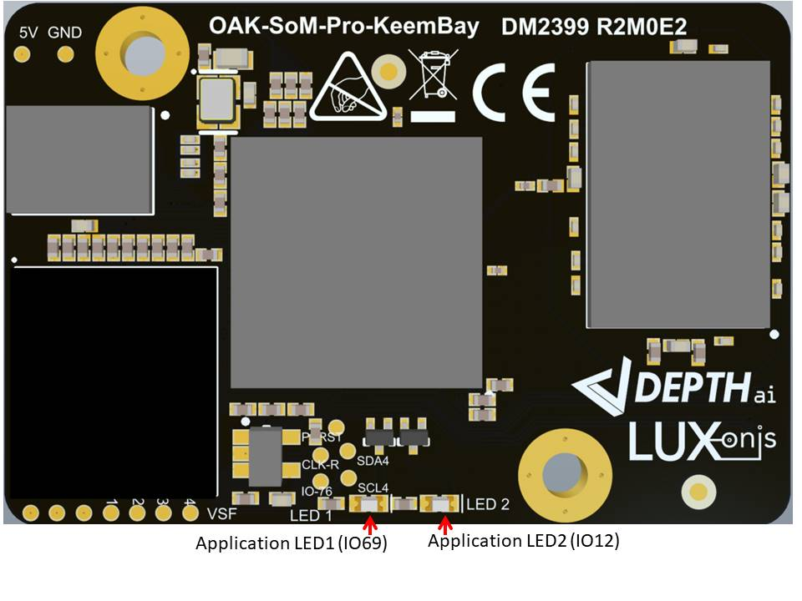

# 8 Mechanical Information

The following information is [the most](http://www.ti.com/corp/docs/legal/termsofuse.shtml) [current](http://www.ti.com/corp/docs/legal/termsofuse.shtml) data available for the designated device. This data is subject to change without notice and without revision of this document.

## 8.1 OAK-SoM-Pro-S3 Dimensions

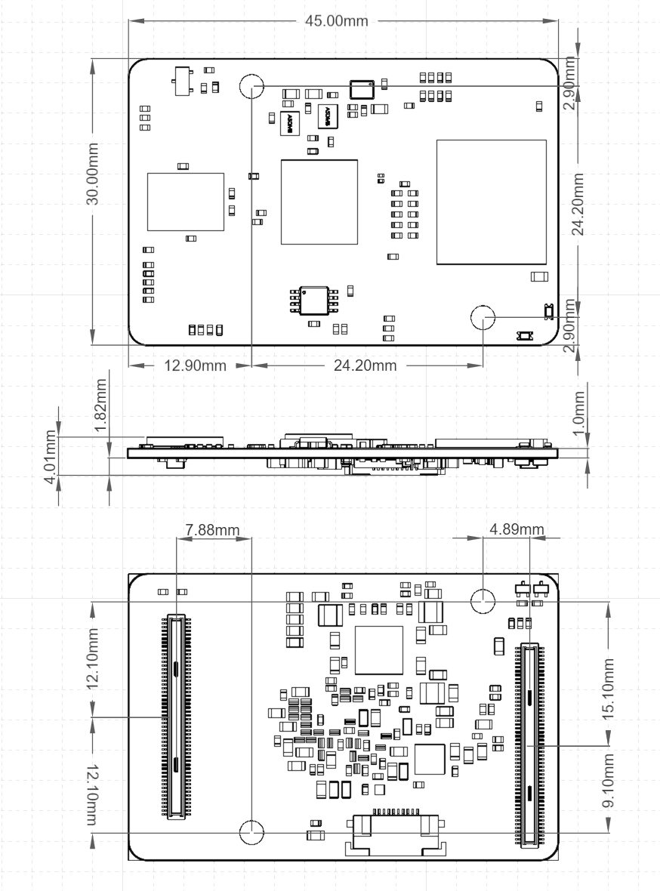

Figure 9 – Top, Side, and Bottom dimensions

## 8.2 Recommended Mounting Configuration

The OAK-SoM-Pro-S3 SoM is designed to be used with a 3mm mated-height connector and accompanying 3mm standoffs. The B2B connector plugs are on the OAK-SoM-Pro-S3 (Hirose DF40C-100DP-0.4V), while the receptacle, which determines mated height, is on the baseboard (Hirose DF40HC(3.0)-100DS-0.4V). Wuerth Elektronik 9774030243R SMT standoffs are recommended.

## 8.3 OAK-SoM-Pro-S3 Mounting Holes

The OAK-SoM-Pro-S3 has 2 M2.5 mounting holes for securing the SoM. These mounting holes use a 2.6mm ID, and a 5.5mm OD pad, which is tied to SoM GND. M2-0.40 screws can be used with these pads to secure the SoM to the recommended Wuerth Elektronik 9774030243R SMT standoffs, or a custom solution using M2-0.40 or M2.5-0.45 screws can be used. Note that when using M2.5-0.45 screws, there is reduced tolerance between the B2B connector clocking and the screws’ hole alignment. This must be accounted for to ensure proper connector mating.

## 8.4 SoM Clearance

3mm is the board-to-board standoff height when using the recommended mounting configuration, however, components on the underside of the OAK-SoM-Pro-S3 reduce this clearance. For highest design reliability, it is recommended not to place components on the baseboard underneath the SoM, in case that is needed in the design, care must be taken in regard to clearance and noise coupling between SoM ICs and baseboard ICs considering the immunity.

In previous designs many components have been successfully placed on the baseboard beneath the SoM making careful use of the 3D STEP file of the SoM, which is available online here [OAK-SoM-Pro-S3](https://github.com/luxonis/depthai-hardware/tree/master/SoMs/OAK-SoM-Pro-S3).

# 9 Thermal Information

Power consumption can vary considerably depending on the application. A stereo vision application running Mobilenet-SSD V2 at 30fps typically consumes about 5.5W, but more aggressive applications can consume closer to 8W. Most of this power is consumed by the VPU. While the VFBGA provides an excellent thermal path from the VPU to the SoM, the thermal sink is small, and the part temperature can quickly rise toward the 105C max die temperature.

Heatsinking of the VPU is required for most applications.

Table 2 details thermal parameters for the VPU simulated in a still air environment, an ambient temperature of 25C, 2W power dissipation, and under the test conditions described in JESD51-2A.

|  |  |  |
| --- | --- | --- |
| **Parameter** | **Value (C/W)** | **Description** |
| θJB | 5.95 | Junction-to-board thermal resistance (EIA/JESD51-8) |
| θJC | 0.029 | Junction-to-case thermal resistance |
| θJA | 19.30 | Junction-to-ambient thermal resistance (EIA/JESD51-2) |

Table 2 - MA2485 Thermal Parameters

# 10 Revision History

* Initial Release – Jan 2023